Instructions for preparation of abstracts for ISWAMP 2023
please restrict the title to two lines

P Hoton^{1 *}, E L Ectron^{2 †} and A Tom^{1,2}

¹Affiliation with laboratory and/or university name, city, zip code, country
²Affiliation with laboratory and/or university name, city, zip code, country

Synopsis Replace this text with your synopsis. The synopsis should be 16 cm wide. Keep it concise at a maximum length of 600 characters including spaces. Use single-spaced lines with 10 pt Roman font.

This is a sample abstract for ISWAMP 2023. The best way to follow all the guidelines spelled out below is to use the word or latex template provided on the conference website.
1. Abstracts should be written in English. The abstract should fit on one A4 page (210 mm × 297 mm) and should come without a page number. It should be submitted in PDF format through the conference website. Files larger than 5 MB will be rejected.
2. It is your responsibility to check that the abstract is correctly formatted and readable. Incorrectly formatted abstracts will be rejected. Do not modify the pre-defined margins.
3. Use 11 pt Roman font for the text or a similar font such as Times New Roman throughout the abstract. Font sizes are listed in table 1.

Table 1. Font sizes to be used in the abstract.
 | Title | Authors,  Body | Affiliations,  Synopsis,  References
Size | 14 pt | 11 pt | 10 pt

4. The title should be typed in 14 pt boldface font and centred.
5. Leave a single (9 pt) empty line after the title line(s), after the author(s) list and after the affiliation(s) list.
6. Leave an empty line of 18 pt after the sy-nopsis. Type the body text in two-column format with 0.75 cm column separation. The text should be single-spaced and the first line of each paragraph should be indented by 0.5 cm.
7. Only one figure file, which may display subfigures, is allowed. It will be shown in colour in the electronic version of the abstract. Provide a separate figure caption (10 pt) which, like a table caption (10 pt), should be concise. If you submit a colour figure it is your responsibility to ensure that it is easy to read and understand even in grayscale mode. When including the figure, pay close attention that your final PDF file does not exceed the 5 MB size limit.
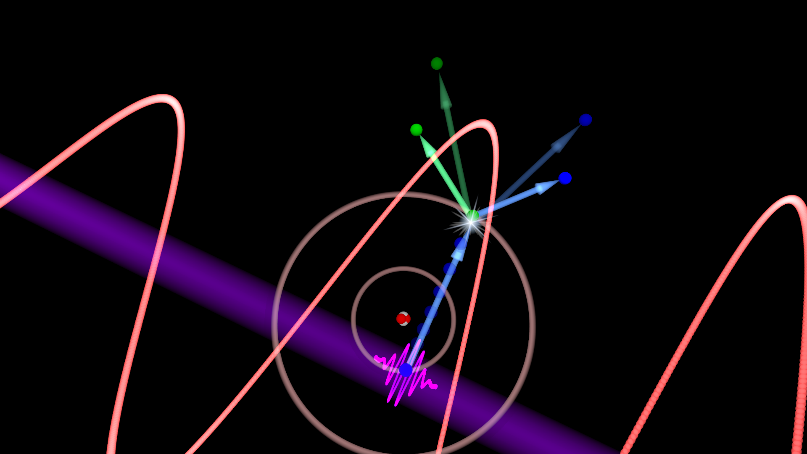
Figure 1. This is a caption for your one and only figure.
8. References in the text should be given by numbers in square brackets [1, 2] (“Vancouver system”). The list of references (10 pt) follows the last line of the text with one extra line inserted. Follow the style of Ref. [1] below.

References
[1] Strickland D and Mourou G 1985 Opt. Commun. 56 219
[2] Reference 2 and so on

_________________________________________________________
* E-mail: corresponding.author1@abcdef.ca
† E-mail: corresponding.author2@ghijkl.ca

